How to pair Q bulbs with your Q Station

Before pairing light bulbs to your Q Station, make sure your Q Station is powered on.
3 easy steps can let you finish the pairing

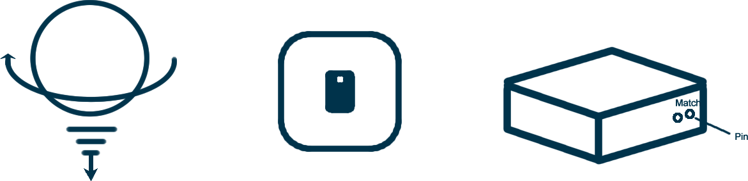

1. Screw in light bulbs
2. Turn on light bulbs
3. Use pin to push down match button for 1 click

Wait a few seconds and your light bulbs will be blinking and steadily on with green color. It means your light bulbs has been paired with your Q Station.

If you found some bulbs was not turned green, please try above steps once again.

